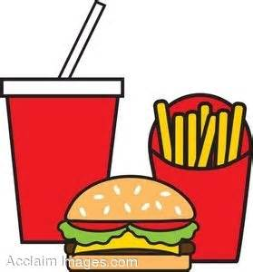 Fast Food Name_______________________________

Directions: Use the nutrition facts information from fast food restaurants to create meals. The nutrition information can found online through the restaurants websites, for example http://www.mcdonalds.com/us/en/home.html. All the fast food websites have the nutrition info, you just have to search around their website for it. Each meal must have at least 2 food items and a drink, and the number of calories for the meal must be at least 500 calories. Try to make each meal something that someone might realistically eat.
Meal #1: Restaurant:________________________________
Food Item | # of Calories | Fat (g) | Sugar (g) | Sodium (Mg)
Totals

Meal #2: Restaurant:________________________________
Food Item | # of Calories | Fat (g) | Sugar (g) | Sodium (Mg)
Totals

Meal #3: Restaurant:________________________________
Food Item | # of Calories | Fat (g) | Sugar (g) | Sodium (Mg)
Totals

Make a list of 5 healthier items from the fast food menu. Describe what makes it a better choice.
Food Item | Why is it a healthier choice?
1.
2.
3.
4.
5.

What nutritional factors make most fast food unhealthy choices?

What health concerns are related to eating fast food?

After completing this activity will you eat less fast food? Why or why not?

